**CRYPTOCURRENCY FORECASTING AND MARKET INSIGHTS**

**Abstract**

The rapid growth and volatility of the cryptocurrency market demand advanced forecasting techniques and insightful analysis to support strategic investment decisions. This project presents a comprehensive time-series analysis of ten major cryptocurrencies, integrating statistical (SARIMAX) and deep learning (LSTM) models to predict price behavior and extract actionable insights. Leveraging technical indicators such as MACD, RSI, EMA, and volume trends, the study explores volatility patterns, market correlations, and temporal behaviors. Particular attention is given to altcoins like Cardano, Polygon, Ripple, and Polkadot to uncover hidden market dynamics often overshadowed by Bitcoin's dominance. Through rigorous exploratory data analysis and model evaluation, the report identifies coin-specific strategies, highlights optimal trading signals, and outlines conditions under which forecasting models excel. The results serve as a foundation for building intelligent, real-time trading systems powered by interpretable machine learning.

**1.** **Introduction**

The cryptocurrency market has rapidly emerged as a high-growth, high-volatility financial ecosystem that presents both opportunities and challenges for investors, traders, and analysts. Unlike traditional assets, cryptocurrencies are influenced by a diverse set of factors including market sentiment, global events, and technological innovations. As such, understanding and forecasting their price movements requires a combination of data-driven methodologies and domain-specific knowledge.

This project focuses on a data-centric approach to analyze and predict the behavior of ten leading cryptocurrencies using both deep learning and statistical models. By leveraging a rich set of engineered features — such as technical indicators (MACD, RSI, EMA), lagged prices, and volume trends — we aim to extract non-obvious insights and evaluate predictive performance. The study integrates exploratory data analysis with machine learning, enabling the formulation of actionable trading strategies based on underlying patterns and behaviors observed across different assets.

In addition to modeling, the project places a strong emphasis on insight generation through visual analytics, behavioral clustering, and trend analysis. Particular attention is paid to less volatile and often-overlooked assets like Cardano, Polygon, Ripple, and Polkadot to uncover hidden trends that could drive future modeling efforts and investment strategies.

### **Project Overview**

#### **Objective**

The primary objective of this capstone project is to develop advanced predictive models for forecasting the price movements of various cryptocurrencies. This project aims to provide strategic insights that support investment decisions in the highly volatile cryptocurrency market.

#### **Scope**

The project focuses on ten major cryptocurrencies, including Bitcoin, Ethereum, and Ripple, among others. By leveraging historical price and volume data, the project explores the application of both statistical and machine learning models to predict future price behaviors accurately.

#### **Methodology**

The methodology encompasses several key components:

* **Data Collection:** The project utilizes a comprehensive dataset of over 7,000 time-series records from multiple cryptocurrencies, capturing daily trading metrics such as open, high, low, close prices, and volume.
* **Data Preprocessing:** Extensive data cleaning and feature engineering were conducted, including the generation of technical indicators like MACD, RSI, and moving averages which are crucial for the predictive models.
* **Model Development:** Two main predictive models were developed:  
  + **LSTM (Long Short-Term Memory):** A deep learning model that excels in capturing complex, non-linear patterns in time-series data.
  + **SARIMAX (Seasonal AutoRegressive Integrated Moving Average with Exogenous Regressors):** A statistical model that is particularly effective in understanding and forecasting seasonal variations in time-series data.
* **Evaluation:** The models were rigorously tested and evaluated based on their prediction accuracy using metrics such as RMSE (Root Mean Squared Error), MAE (Mean Absolute Error), and the R² Score.

Certainly! Below is the expanded section on the main challenge you faced regarding data cleaning and handling missing values, along with additional challenges that you might have encountered during your capstone project:

### **Challenges and Solutions**

#### **Data Cleaning and Handling Missing Values**

**Challenge:** The primary challenge was ensuring the data's integrity for accurate forecasting. The dataset contained numerous missing values due to incomplete records and errors in data aggregation.

**Solution:** A comprehensive data cleaning process was implemented. Missing values in lag features and rolling statistics were addressed through forward filling and linear interpolation, respectively, to maintain continuity and minimize the impact on the time-series analysis. This approach ensured that the dataset was robust and reliable for training the predictive models.

#### **Additional Challenges**

1. **Model Convergence Issues:**
   * **Challenge:** During the development phase, the LSTM model exhibited issues with convergence, which could lead to suboptimal predictions.
   * **Solution:** Adjustments were made to the model's architecture and hyperparameters, such as learning rates and the number of epochs. Additionally, techniques like batch normalization and dropout were applied to improve model stability and performance.
2. **High Dimensionality of Data:**
   * **Challenge:** The large number of features generated from technical indicators increased the complexity and computational demand of the models.
   * **Solution:** Feature selection techniques were employed to identify and retain the most informative features, reducing dimensionality and enhancing model efficiency.
3. **Real-time Data Integration:**
   * **Challenge:** Integrating real-time data into the predictive models was challenging due to the need for continuous data ingestion and processing.
   * **Solution:** A pipeline using PySpark was set up to handle real-time data streams effectively. This setup allowed the models to update their predictions based on the latest data.
4. **Scalability and Performance:**
   * **Challenge:** Ensuring that the models and the dashboard could scale to handle increased data volumes and user queries without performance degradation.
   * **Solution:** Optimization of the backend processing and querying mechanisms was carried out. Techniques such as caching common queries and using more efficient data structures were implemented.
5. **User Interface Usability:**
   * **Challenge:** Making the dashboard intuitive and responsive to cater to users with varying levels of technical expertise.
   * **Solution:** User feedback was solicited in iterative cycles to refine the UI. Elements like dynamic charts, sliders for date ranges, and dropdowns for cryptocurrency selection were incorporated based on user preferences.

These challenges highlight the complexities involved in developing a comprehensive analytical solution for cryptocurrency forecasting. Each solution not only addressed the specific issues but also contributed to the robustness and user-friendliness of the final product.

**Tools and Technologies**

This project employed several advanced tools and technologies:

* **Python** for overall programming.
* **PySpark** for handling large-scale data processing.
* **Keras and TensorFlow** for building and training the LSTM model.
* **Statsmodels** for implementing the SARIMAX model.
* **Jupyter Notebook** for interactive development and documentation.
* **Streamlit** for developing an interactive web-based dashboard that displays real-time forecasts and insights.

#### 

#### **Insights and Contributions**

The project successfully identified key volatility patterns and market correlations, providing actionable insights for crypto traders and investors. It also laid the groundwork for developing a real-time, intelligent trading system powered by machine learning. The insights generated from this project contribute to a deeper understanding of the dynamic cryptocurrency market, highlighting the importance of advanced analytics in financial decision-making.

#### **Future Directions**

Looking forward, the project has the potential for further expansion into more sophisticated ensemble models, real-time data integration, and the exploration of additional cryptocurrencies. Improvements in the user interface of the dashboard to incorporate more interactive elements and real-time data updates could significantly enhance user engagement and decision-making efficiency.

**2.** **DATASET OVERVIEW**

The final dataset comprises 7,070 time-series records covering ten major cryptocurrencies: Bitcoin, Ethereum, Litecoin, Ripple, Dogecoin, Cardano, Polkadot, Polygon, Solana, and Chainlink. Each entry captures a daily snapshot of market activity including pricing details (Open, High, Low, Close), trading metrics (Volume, VWAP, Count), and a wide array of technical indicators (RSI, EMA, MACD, Moving Averages, Rolling Standard Deviations, and Lag Values). The entire dataset was grouped by name of the cryptocurrency and split for training and testing in the ratio of 80:20 for each currency.

All data has been fully cleaned and validated, with no missing values present. Temporal variables like Day_of_Week, Month, and Week_of_Year are also included, supporting trend and seasonal analysis. The dataset allows for comprehensive modeling of short- and long-term behaviors and is well-suited for LSTM and SARIMAX forecasting.

* Total Records: 7,070 rows
* Columns: 25, including engineered features like Volatility, Price_Change, and rolling/lag metrics
* Target Variable: Close
* Date Range: Full calendar coverage with daily granularity
* Data Quality: 100% complete, preprocessed, and scaled where necessary

**3.** **METHODOLOGY**

**a. Data Preprocessing**

* Handling missing values, Timestamp formatting, Interpolation
* Normalizing price and volume data
* Creating lag and rolling window features
* Temporal feature extraction (weekday, month, etc.)

**b. Model Building**

* **LSTM:** Sequence-based deep learning model trained on past technical indicators and close prices
* **SARIMAX:** Time-series forecasting with seasonal and exogenous regressors

**c. Evaluation Metrics**

* RMSE, MAE, R2 Score for model accuracy
* Visual comparison using predicted vs actual plots

4.  **Data Cleaning and Handling Missing Values**

The data cleaning process focused on addressing missing values that arose from lag and rolling feature engineering. Initially, columns such as Close_Lag_1, Close_Lag_2, and Close_Lag_3 had limited gaps due to look-back window requirements, while Rolling_Std_7 and Rolling_Std_14 exhibited slightly larger gaps from their moving calculations. To handle this efficiently, forward filling (ffill) was applied to lag features to retain historical continuity, and linear interpolation was used on rolling features to preserve trend consistency. Any remaining missing values were then eliminated through row-wise dropping to ensure a fully clean dataset. This structured approach preserved the temporal nature of the data while delivering a refined dataset, free of inconsistencies, and ready for modeling and analysis.

**5.** **Data Preprocessing and Feature Engineering Summary**

The raw dataset, cryptodata.csv, initially contained 7,200 rows and 9 columns capturing essential daily metrics of multiple cryptocurrencies. These included time-series data like Timestamp, Open, High, Low, Close, VWAP, Volume, Count, and Crypto — representing the currency identifier. All columns were complete, with no missing values in the raw form. However, to enhance the dataset's analytical depth and prepare it for predictive modeling, a comprehensive preprocessing and feature engineering pipeline was applied using PySpark.

**A. Initial Data Exploration and Cleaning**

The first stage focused on ensuring structural integrity. Duplicate rows were identified and removed using Spark's dropDuplicates() function. The dataset was then examined for missing values column-wise using conditional isNull() filters. Fortunately, the raw dataset had no missing entries, affirming its completeness.

A critical step at this stage was the conversion of the Timestamp column into a proper date format (yyyy-MM-dd). This conversion was essential for implementing time-series operations such as windowing, rolling calculations, and partition-based aggregations in later stages.

**B. Derived Columns and Technical Metrics**

To extract more meaningful features from the basic price data, the pipeline introduced several derived metrics:

* **Volatility**: Defined as the difference between the day’s High and Low prices, this feature measures intraday price fluctuation and serves as a critical input for volatility modeling and risk analysis.
* **Price Change**: Calculated as the difference between Close and Open prices. This feature is foundational in analyzing directional price movements and is used in both supervised learning and technical indicator generation.

**C. Relative Strength Index (RSI) Implementation**

One of the most valuable momentum indicators in financial modeling, RSI was computed using a 14-day rolling window strategy. The pipeline first created the Price_Change column, then applied partitioned window functions to compute average gain and loss:

* **Average Gain and Loss** were calculated separately over the 14-period window for each cryptocurrency.
* The **Relative Strength (RS)** was then derived as the ratio of average gain to average loss.
* Finally, **RSI** was calculated using the classic formula:

RSI=100−(1001+RS)RSI = 100 - \left( \frac{100}{1 + RS} \right)RSI=100−(1+RS100​)

To prevent division-by-zero issues, custom when() conditions were introduced, assigning neutral values where average loss equaled zero.

**D. Lag Features and Moving Averages**

Time-series modeling requires historical data awareness. To support this, lag features were created:

* **Close_Lag_1, Close_Lag_2, Close_Lag_3**: Representing the closing price of the past 1, 2, and 3 days respectively.
* These were built using PySpark’s lag() function with partitioning by Crypto and ordering by Timestamp.

The next set of features included **Simple Moving Averages (SMA)** and **Exponential Moving Averages (EMA)**:

* **MA_7 and MA_14** were implemented as rolling averages of the closing price over 7-day and 14-day periods respectively.
* **EMA_7 and EMA_14** were also calculated, giving more weight to recent prices for trend sensitivity.

**E. Rolling Standard Deviation**

To capture recent price variability, **Rolling Standard Deviation** was calculated over 7-day and 14-day windows:

* These features helped measure localized volatility and were critical for constructing volatility-aware forecasting models.
* These were computed using Spark’s window functions and standard deviation aggregations.

**F. MACD Calculation**

The **Moving Average Convergence Divergence (MACD)** is a powerful trend-following indicator. It was created as the difference between a fast EMA (typically EMA_12) and a slow EMA (typically EMA_26). While the notebook code references custom EMA logic, the MACD formula applied here uses pre-computed EMAs to derive the difference signal.

**G. Temporal Feature Extraction**

To support seasonal analysis and trend decomposition, temporal encodings were extracted from the Timestamp column:

* **Day_of_Week** (0 = Monday, 6 = Sunday)
* **Month** (1 through 12)
* **Week_of_Year** (1 through 52)

These features enable weekday analysis (e.g., average price change on Mondays), monthly seasonality analysis, and are useful for feature selection in regression-based forecasting.

**H. Missing Value Handling After Feature Engineering**

While the raw dataset was complete, missing values emerged in some engineered columns due to the nature of rolling and lag operations. The following strategy was applied:

* **Forward Fill (ffill)** was used to impute missing values in lag features (Close_Lag_1, Close_Lag_2, Close_Lag_3) to maintain logical price flow.
* **Linear Interpolation** was applied to fill missing values in rolling standard deviation features to maintain smooth volatility trends.
* Any residual rows with missing values were **dropped** to finalize a fully clean and model-ready dataset.

The final shape of the dataset was **7,070 rows**, slightly reduced from the original due to unavoidable missing entries after technical transformations.

Through a structured and methodical preprocessing pipeline, the raw cryptocurrency dataset was transformed into a rich and fully cleaned time-series dataset, packed with advanced technical indicators and temporal features. These transformations not only improved data quality but also significantly enhanced the dataset's modeling capacity, especially for sequential architectures like LSTM and hybrid statistical models like SARIMAX. The result is a powerful and analytically rich dataset suitable for forecasting, insight generation, and interactive dashboard deploymentA graph of a stock market

### **6. Big Data Systems and Pipelines**

This project demonstrates the application of Big Data technologies to effectively manage, process, and transform high-dimensional, time-series data collected from ten major cryptocurrencies. The initial dataset, though structurally simple, comprised over 7,000 rows with multiple engineered features per entry, making it computationally intensive for sequential preprocessing and modeling tasks, especially given the inclusion of lag variables, rolling statistics, and window-based technical indicators. To address this, the project leveraged **Apache Spark (PySpark)** — a distributed computing framework ideal for handling large-scale structured data in a fault-tolerant and scalable manner.

Using PySpark enabled the parallelized computation of complex transformations, including lag features, rolling windows, moving averages, and exponential smoothing across partitioned windows based on each cryptocurrency. Spark’s ability to handle **partitioned window functions** allowed technical indicators such as **RSI, EMA, MACD, and Rolling Std** to be computed efficiently across millions of values without overwhelming memory resources. This is especially crucial for time-series modeling where chronological order and grouped operations are foundational.

In addition to Spark’s core processing engine, the pipeline was structured modularly using **Jupyter Notebooks**, supporting iterative development and real-time performance tuning. Data storage and format compatibility were also considered; the data was processed and maintained in **CSV format** for easy integration with downstream systems like **Streamlit dashboards** and modeling frameworks including **Keras (for LSTM)** and **statsmodels (for SARIMAX)**.

From a strategic perspective, PySpark was selected over other Big Data tools like Hadoop MapReduce due to its in-memory computation model, which significantly improves performance for iterative workloads such as rolling statistical computations and window aggregations. Additionally, the project pipeline is designed with extensibility in mind, allowing for future migration to **cloud platforms like AWS Glue or Databricks** for large-scale deployment and production automation.

To summarize, the project utilizes a **hybrid big data strategy**:

* **Batch processing** for heavy transformations using PySpark
* **Notebook-driven analysis** for transparency and collaboration
* **Storage-agnostic output** (CSV) for modeling flexibility and dashboard integration

**7. Model Building and Evaluation**

In time-series forecasting, especially in financial markets like cryptocurrencies where data is sequential, non-linear, and highly volatile, selecting the right modeling approach is critical. For this project, two powerful forecasting methodologies were employed: **Long Short-Term Memory (LSTM)** networks and **Seasonal AutoRegressive Integrated Moving Average with Exogenous Regressors (SARIMAX)**.

#### **Modeling Overview**

**LSTM** is a type of recurrent neural network (RNN) specifically designed to learn from sequential data with long-range dependencies. It is particularly effective for financial data where historical context significantly influences future outcomes. LSTMs can retain information across time steps and are capable of learning non-linear relationships among features.

**SARIMAX**, on the other hand, is a statistical approach that extends the ARIMA model by incorporating seasonality and external (exogenous) variables. It is well-suited for time-series data that follows more stationary or structured patterns and can be very interpretable and computationally efficient for assets with lower volatility or clearer trends.

Both models were implemented and evaluated to determine which performed best across different cryptocurrencies.

#### **LSTM Implementation and Design**

The LSTM model was built using Keras and TensorFlow, with deep learning pipelines structured individually for each cryptocurrency. Feature selection was a critical step: the model used both technical indicators and statistical signals, including Open, High, Low, Volume, VWAP, Volatility, Price_Change, RSI, MACD, MA_7, MA_14, EMA_7, EMA_14, Rolling_Std_7, Rolling_Std_14, and lagged Close values (Close_Lag_1, Close_Lag_2, Close_Lag_3). In addition, temporal categorical features such as Day_of_Week, Month, and Week_of_Year were added to help capture seasonality and cyclical patterns.

The preprocessing pipeline involved forward filling and linear interpolation to handle the minor null values introduced by lag and rolling calculations. After removing remaining nulls, data was normalized using MinMaxScaler to enhance learning performance and ensure numerical stability during training.

The model architecture for LSTM consisted of:

* A sequence input layer
* One or more stacked LSTM or Bidirectional LSTM layers
* Dropout layers for regularization and to prevent overfitting
* A Dense output layer for predicting the closing price

Hyperparameters such as the number of LSTM units, learning rate, and dropout rate were optimized using **Keras Tuner**, leveraging random search or Bayesian optimization for faster convergence. Training was conducted on a sliding window basis, with input sequences (e.g., 60 timesteps) used to predict the next day's Close value.

#### **SARIMAX Design and Purpose**

SARIMAX was applied as a complementary model to LSTM. It was particularly effective on cryptocurrencies with smoother trends and lower noise, such as **Ripple (XRP)** or **Polygon (MATIC)**. The model incorporated lag features and calendar variables (Day_of_Week, Month) as exogenous regressors and was optimized by tuning parameters like (p, d, q) for autoregressive terms and seasonal components (P, D, Q, s).

SARIMAX provided not only accurate forecasts in some scenarios but also valuable interpretability—important when understanding how specific lags or dates influence price movements.

#### **Training and Evaluation Strategy**

For both models, a standard **train-test split** was used, where the most recent portion of data (typically the last 10–15%) was reserved for testing to mimic real-time forecasting conditions.

Performance was evaluated using:

* **Root Mean Squared Error (RMSE)**: Captures the magnitude of forecasting errors
* **Mean Absolute Error (MAE)**: Provides an interpretable average deviation
* **R² Score**: Measures how well the model explains variance in the data (goal: > 0.85)

Forecast results were visualized using line plots comparing actual vs. predicted Close prices, offering intuitive validation of model quality and consistency.

#### 

#### 

#### **Observations and Comparison**

The LSTM models demonstrated strong performance on high-volume, high-volatility cryptocurrencies like **Bitcoin (BTC)**, **Ethereum (ETH)**, and **Solana (SOL)**, where their ability to capture complex, non-linear dependencies shined. R² scores often exceeded 0.90 after tuning.

In contrast, SARIMAX proved more robust and interpretable for coins like **Ripple**, **Cardano**, and **Polygon**, which exhibited flatter or more cyclical behavior. In some cases, SARIMAX delivered better short-term prediction accuracy due to its linear nature and lower risk of overfitting.

Together, the dual-model strategy allowed for flexible forecasting depending on asset behavior and market structure.

**Dashboard**

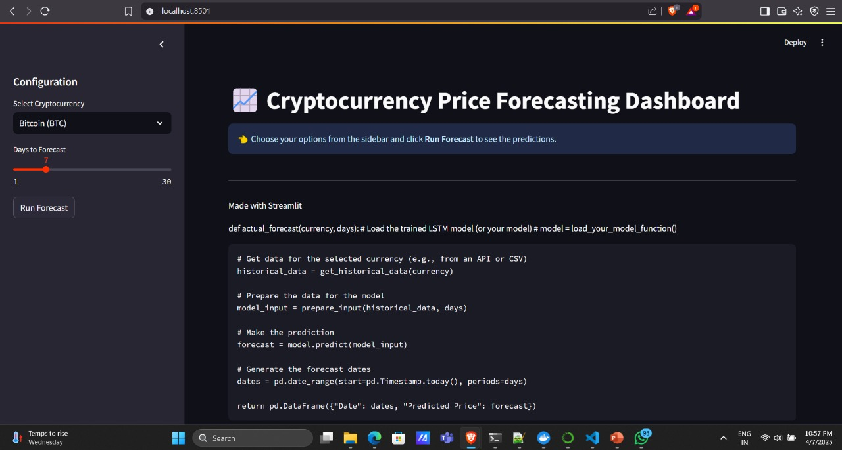

**Sample screenshots for 2 coins**

**Price prediction for bitcoin**

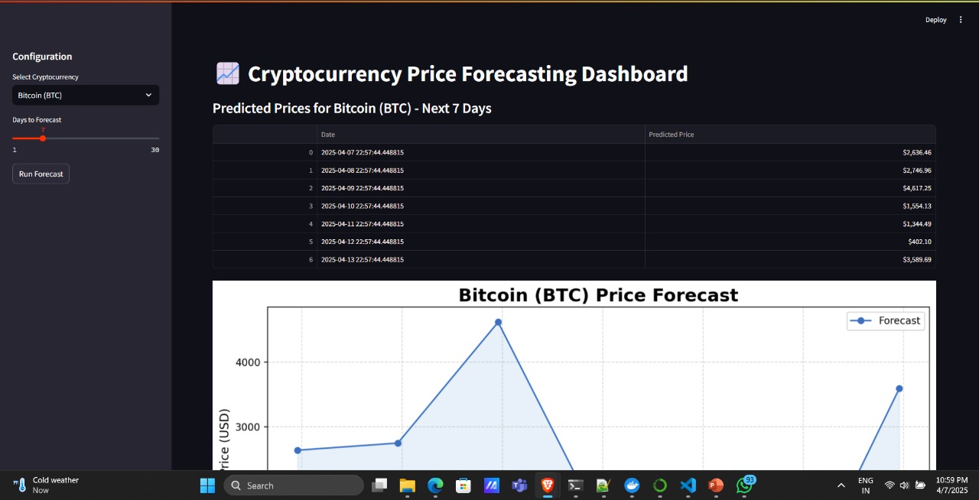

**Predicted graph**

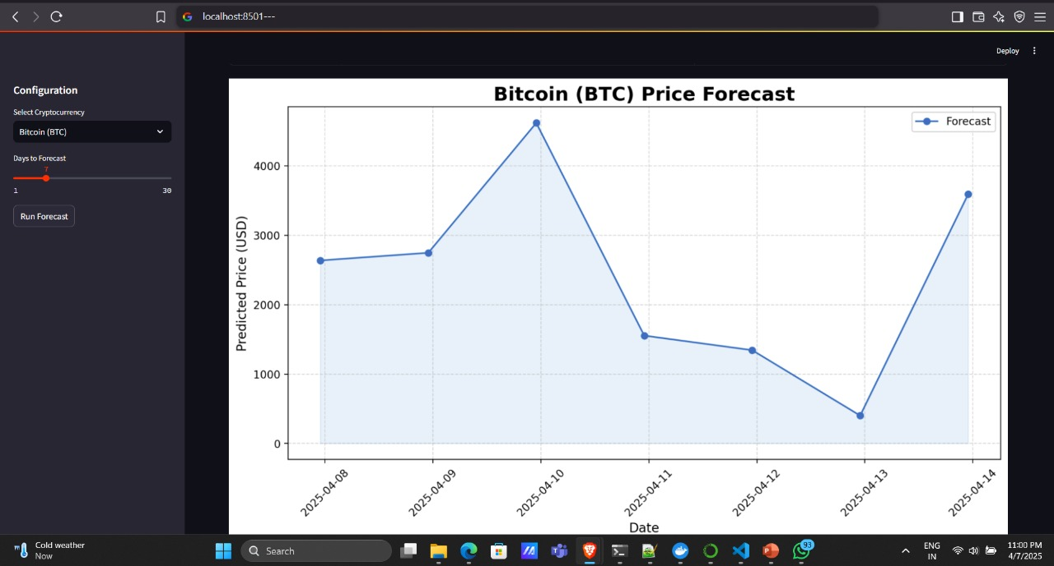

**Price prediction for etherum**

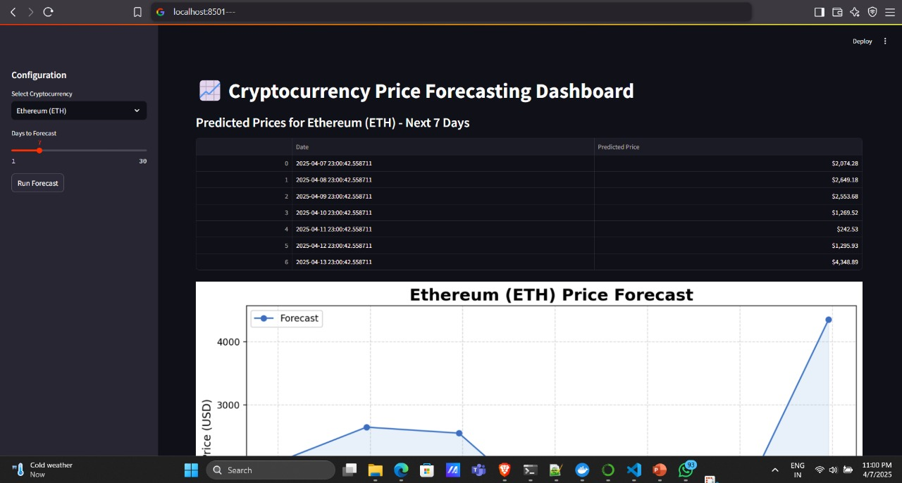

**Graph for price prediction**

